***What is CDP and LLDP?***

CDP ( Cisco discovery protocol)- Allows you to go into a device and see directly attached neighbors

LLDP (Linked layer Discovery protocol) – A carrier / communication tool.

***Configuring and Tuning CDP and LLDP***

Look at the global and interface specific configuration parameter for CDP and LLDP

>#show cdp

See the configuration parameter of CDP

>#lldp ?

>#lldp run

This enables LLDP

(TLV) type length value – the data lldp sends

># int fa2/0/3

>#no lldp

>#no cdp

Which of the following is NOT an option with TLV for LLDP?

Device routes

***Creating a Network Diagram using CDP and LLDP***

How to create a network diagram (perform network discovery) using CDP and LLDP

>#show cdp neighbors

This way you can see the neighbors of other devices and expand your knowledge of the network devices.

>#show cdp entry AZ-SW01

Shows more detailed information about the entry, like ip addresses and other hardware information.

When creating a network diagram, which of the following steps is NOT a good idea?

Turn off a neighboring device to identify the port being down.

***Creating a Network Diagram with CDP Lab***

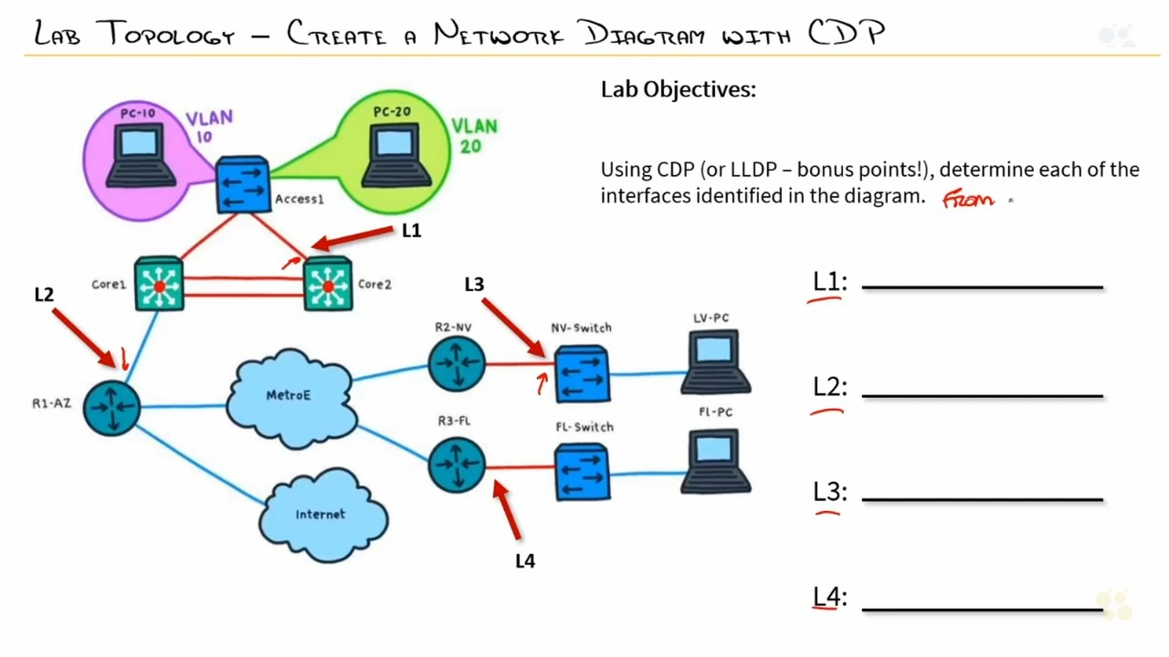

L1: Gig 2/2

L2: Gig 0/0

L3: Gig 3/3

L4: Gig 1/0

|  |  |  |  |  |  |
| --- | --- | --- | --- | --- | --- |
| Device ID | Local Interfc | Holdtme | Capability | Platform | Port ID |
| FL-switch | Gig1/0 | 102 | S I | IOSv | Gig 3/3 |

When you use the show cdp neighbors command you get this information. The local interface is from the hardware you ran the command from. The port id is the interface of the other device you are connected to.

LLDP is running by default on most Cisco routers and switches. True or false?

FALSE

***Review of Create a Network Diagram with Cisco CDP and LLDP***

Which of the following commands will show only cisco connected devices?

Show cdp neighbors

Which of the following is not a TLV option for LLDP?

System name, port vlan, management address are all options for TLV. Device routes are currently not an option.

When creating a network diagram, which of the following steps is not a good idea.

Console into the device and run show ip interface brief is a good idea.

Turn off a neighboring device to identify the port being down is not a good idea.

Input the command ‘show cdp neighbors’ is a good idea.

Map out each device from the cdp results is a good idea.